3GPP TSG RAN WG1 Meeting #125 R1-2603709
Dalian, China, May 18th – 22nd, 2026
Agenda Item: 10.8.3
Source: EURECOM
Title: Waveform and frame structure for ISAC
Document for: Discussion and decision

Introduction
According to Releases 19 and 20 ISAC, the use cases, channel model and evaluation assumptions are defined as follows:
- Five use cases are studied for ISAC:
- UAVs
- Humans indoors and outdoors
- Automotive vehicles
- Automated guided vehicles (e.g. in indoor factories)
- Objects creating hazards on roads/railways, with a minimum size dependent on frequency
- Six sensing modes: transmission reception point (TRP)-TRP bistatic, TRP monostatic, TRP-user equipment (UE) bistatic, UE-TRP bistatic, UE-UE bistatic, UE monostatic are supported in these use cases.
- ISAC channel model is specified in Section 7.9 in TR 38.901.
- Evaluation assumptions and performance metrics are specified in TR 38.765.
A unified design for sensing and communication is required for ISAC use cases.
The following agreements are noted in RAN1#124b:
Agreement:
CP-OFDM waveform as defined for 6GR is the starting point for 6G ISAC waveform study.
Study on enhancements on CP-OFDM or other waveforms is not precluded.
Agreement:
6GR communication frame structure is the starting point for 6G ISAC frame structure study, in at least the following aspects.
- Frame/sub-frame/slot/symbol structure
- CP length
- SCS
Enhancements on frame structure/above aspects are not precluded.
Agreement:
Companies are encouraged to provide views on necessity/pros/cons/metrics of LLS and/or SLS and pros/cons/metrics of theoretical waveform characteristics analysis, for evaluation of ISAC waveform and/or integration with communication, to RAN1#125 meeting.
Agreement:
CP-OFDM is used as the benchmark for evaluating the benefits of sensing waveforms.

Discussion

Slot structure for sensing and communication

DL slots for ISAC
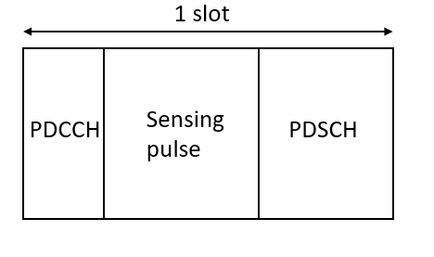
- Continuous PDSCH resource
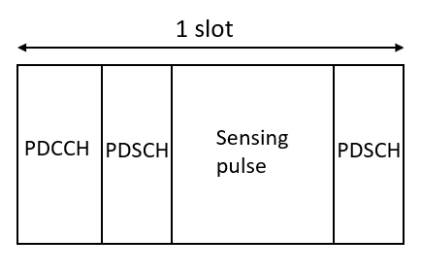
- Discontinuous PDSCH resource
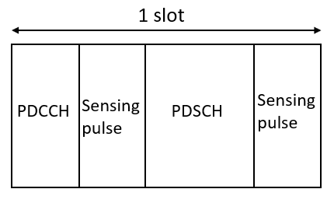
- Discontinuous sensing resource
Figure 1: Slot structure for sensing and communication signals in DL
In the use cases such as UAV and automated guided vehicles, the sensing entities need to detect and track high mobility targets. It requires a short repetition interval of sensing signal to achieve high maximum unambiguous velocity.
At frequency of 5 GHz, in monostatic sensing, the repetition interval must be smaller than 340 $μ$s so that the sensing entity can track the target moving at 160 km/h. With SCS of 15 kHz and 30 kHz, the repetition interval is smaller than one slot. To satisfy the transmission of sensing signal with small repetition interval, a mini-slot structure for communication and sensing signal are needed. As shown in Figure 1, sensing signal and communication signal (PDSCH) are multiplexed in one slot.
With an interval smaller than 340 $μ$s, a sensing signal might be repeated in the middle of a slot that interrupts a communication transmission carried by PDSCH. In this case, as shown in Figure 1b, PDSCH communication can be interrupted in the middle by a sensing transmission. In other words, PDSCH transmission stops and resumes in a slot due to sensing transmission.
The aNB can preconfigure the time and frequency resources in a slot for sensing signal then inform the receiver allowing it to detect the sensing signal in those resources. The aNB sends downlink control information (DCI) contained in PDCCH or radio resource control (RRC) signaling to the UE in order to indicate time and frequency resources of sensing signal. PDCCH used to indicate sensing resource can be transmitted in the same or different CORSET as PDCCH used to indicate communication resource.
Proposal 1: In a DL slot, mini-slot structure is used to multiplex sensing signal and communication signal.
Proposal 2: In a DL slot, communication signal can stop before a sensing transmission the resume after the sensing transmission.
Proposal 3: PDCCH used to indicate sensing resource can be transmitted in the same or different CORSET as PDCCH used to indicate communication resource.

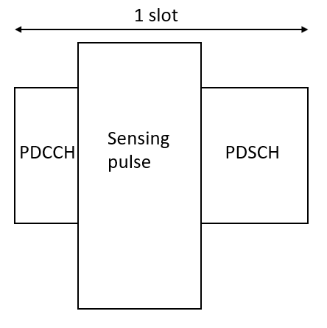
- Continuous PDSCH resource
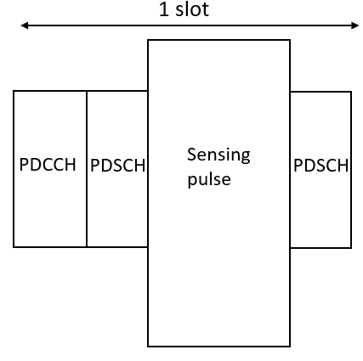
- Discontinuous PDSCH resource
Figure 2: DL slot structure with higher bandwidth for sensing signal
For sensing signals, a higher bandwidth allows greater sensing accuracy with improved range resolution. In the applications with strict sensing accuracy requirement, more frequency resources are allocated to transmit sensing signal. In a slot, bandwidth of sensing resource is increased while the other parameters such as bandwidth of communication resource are kept the same. In Figure 2, sensing resources are increased in terms of frequency while bandwidth of communication resource for PDCCH and PDSCH is kept the same.
The slot structures in Figure 2 are configured by the aNB based on the requirements of sensing applications through DCI or RRC signaling. The aNB defines the new bandwidth of sensing resource and the number of slots where new bandwidth is used for sensing. Then after the last slot defined by the aNB, bandwidth of sensing resource in the next slots returns to match bandwidth of communication resource as shown in Figure 1 to serve the applications with lower sensing accuracy requirement.
Proposal 4: The aNB dynamically increases the bandwidth of the sensing resource through DCI or RRC signaling to serve the sensing applications with high sensing accuracy requirement while still keep the bandwidth of communication resource in the same DL slot unchanged.
Proposal 5: The aNB indicates to the UE through DCI or RRC signaling the number of slots where an increased bandwidth of sensing resource is applied.

UL slots for ISAC
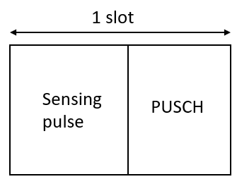
- Continuous PUSCH resource
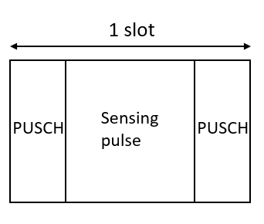
- Discontinuous PUSCH resource
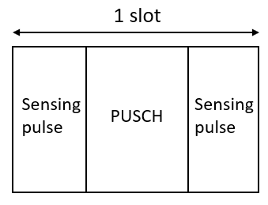
- Discontinuous sensing resource
Figure 3: Slot structure for sensing and communication signals in UL
In UL slot, sensing signal and communication signal are also multiplexed in a slot following a mini-slot structure as DL slot as shown in Figure 3. Communication signal carried by PUSCH can stop before a sensing transmission and resume after a sensing transmission in a slot as shown in Figure 3b.
In one mode, sensing resources are preconfigured to the UE by the aNB through DCI or RRC signaling. The period of sensing resources is indicated by DCI or RRC signaling. In another mode, the UE requests the aNB to configure sensing resource through uplink control information (UCI) when it needs to carry out a sensing task then the aNB configures sensing resource through DCI.
PDCCH used to indicate sensing resource can be transmitted in the same or different CORSET as PDCCH used to indicate communication resource.
Proposal 6: In an UL slot, mini-slot structure is used to multiplex sensing signal and communication signal.
Proposal 7: In an UL slot, communication can stop before a sensing transmission then resume after the sensing transmission.
Proposal 8: In one mode, sensing resources are preconfigured to the UE by the aNB through DCI or RRC signaling. The period of the sensing resources is indicated by DCI or RRC signaling.
Proposal 9: In another mode, the UE requests the aNB to configure sensing resource through UCI when it needs to carry out sensing task then the aNB configures sensing resource through DCI.

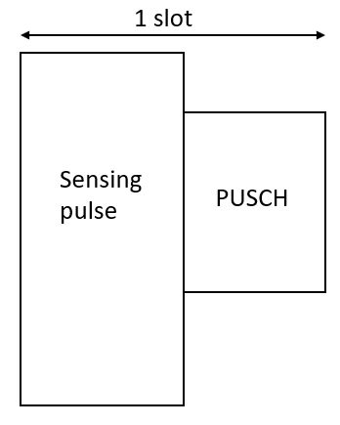
- Continuous PUSCH resource
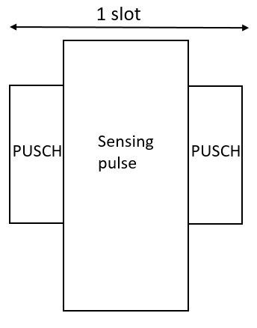
- Discontinuous PUSCH resource
Figure 4: UL slot structure with higher bandwidth for sensing signal
In the applications with strict sensing accuracy requirement, more frequency resources are allocated to transmit sensing signal. In an UL slot, bandwidth of sensing resource is increased while the other parameters such as bandwidth of communication resource are kept the same as shown in Figure 4.
Proposal 10: In an UL slot, bandwidth of sensing signal can be increased to be bigger than bandwidth of communication signal to serve the applications with strict sensing requirements.

Conclusion
Proposal 1: In a DL slot, mini-slot structure is used to multiplex sensing signal and communication signal.
Proposal 2: In a DL slot, communication signal can stop before a sensing transmission the resume after the sensing transmission.
Proposal 3: PDCCH used to indicate sensing resource can be transmitted in the same or different CORSET as PDCCH used to indicate communication resource.
Proposal 4: The aNB dynamically increases the bandwidth of the sensing resource through DCI or RRC signaling to serve the sensing applications with high sensing accuracy requirement while still keep the bandwidth of communication resource in the same DL slot unchanged.
Proposal 5: The aNB indicates to the UE through DCI or RRC signaling the number of slots where an increased bandwidth of sensing resource is applied.
Proposal 6: In an UL slot, mini-slot structure is used to multiplex sensing signal and communication signal.
Proposal 7: In an UL slot, communication can stop before a sensing transmission then resume after the sensing transmission.
Proposal 8: In one mode, sensing resources are preconfigured to the UE by the aNB through DCI or RRC signaling. The period of the sensing resources is indicated by DCI or RRC signaling.
Proposal 9: In another mode, the UE requests the aNB to configure sensing resource through UCI when it needs to carry out sensing task then the aNB configures sensing resource through DCI.
Proposal 10: In an UL slot, bandwidth of sensing signal can be increased to be bigger than bandwidth of communication signal to serve the applications with strict sensing requirements.

